Kaleb Alstott

LAB 2 – Environment Variables

TASK 1

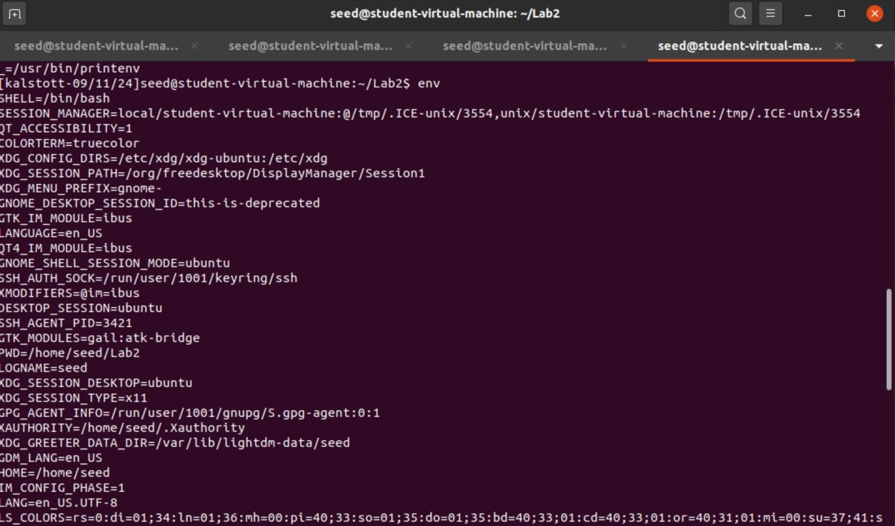

Step 1 – In this step and in the command above we are tasked with printing out our current environment variables. We do so by running the “env” command.

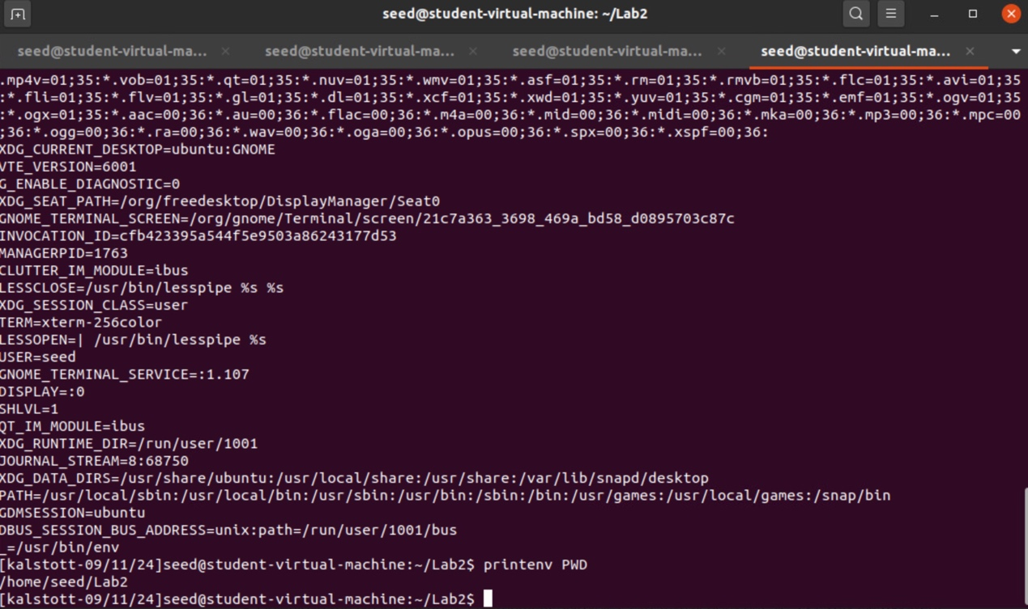

Step 2 – In this step and command, I followed through with the assignment and went out to test printenv PWD from curiosity. Which above you can see prints working directory environment variables.



Step 3 – In this step we used the command export to set our environment variable which we can see is set as MY_VAR_TASK1 = “This is kaleb”. When we print out our environment variables it should read “This is kaleb”.

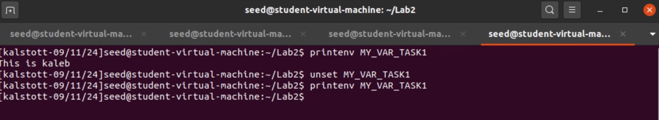

Step 4- In this step we use the command printenv to print our environment variable. We also show the command of unset which unsets our environment variable. This is shown when we try to run our printenv and comes back blank.

TASK 2

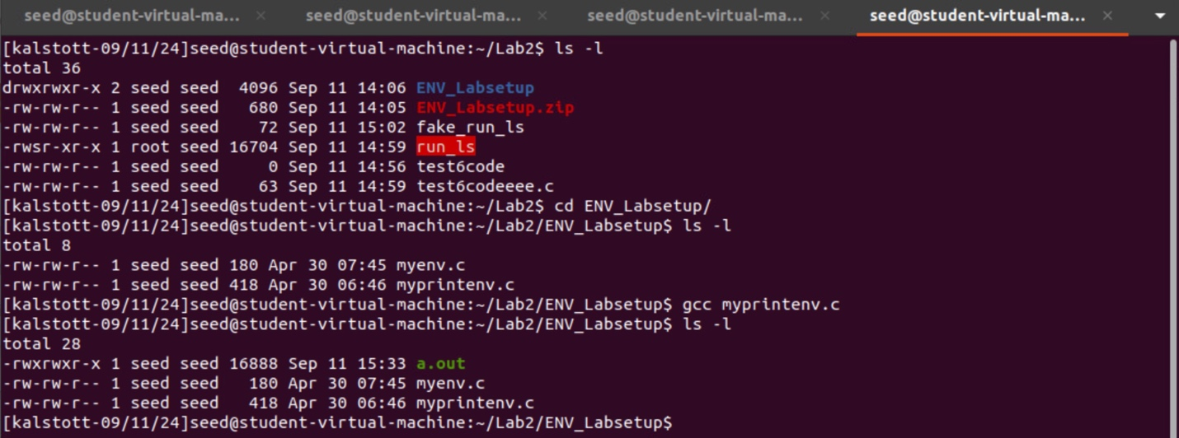

Step 1 - After transporting and organizing the zip file that was given to us we followed the instructions given and used the command gcc to compile our myprintenv.c, "gcc myprintenv.c", When compiled we generated a binary called a.out.



Our next steps here were to save the output into a file named “file”. We were able to run the command “./a.out > file” given to us in our document to save this output to “file”.

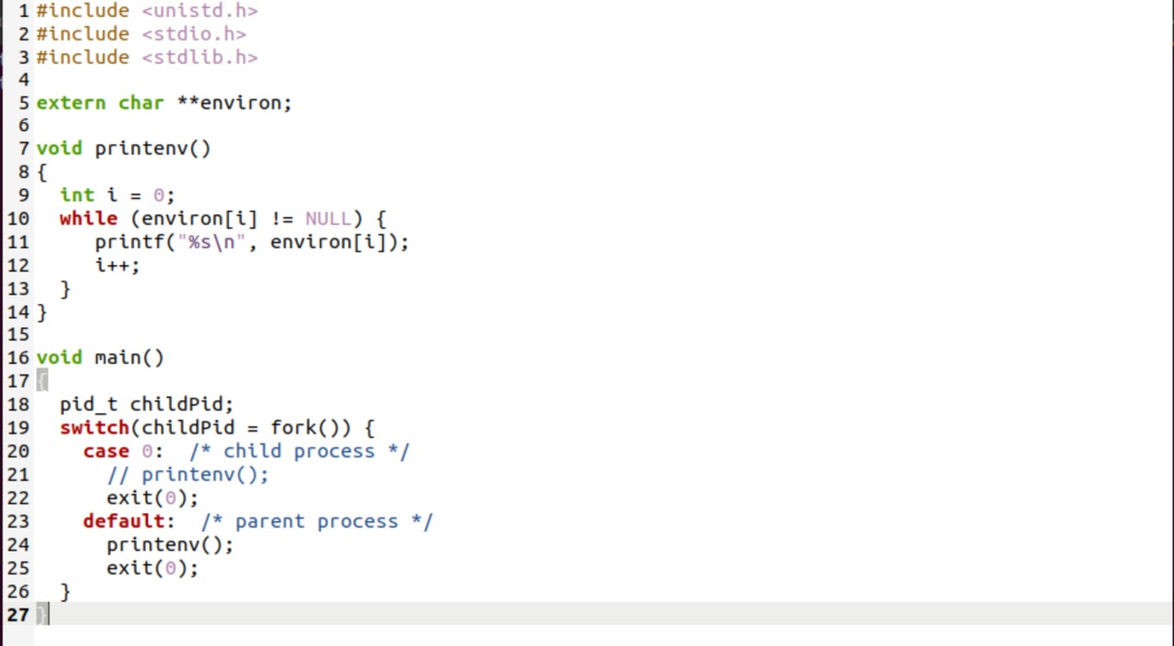

Step 2 – We now comment out the printenv() statement in the child process case (Line ➀), and uncomment the printenv() statement in the parent process case (Line ➁). This should call to our parent process instead of the child process now.

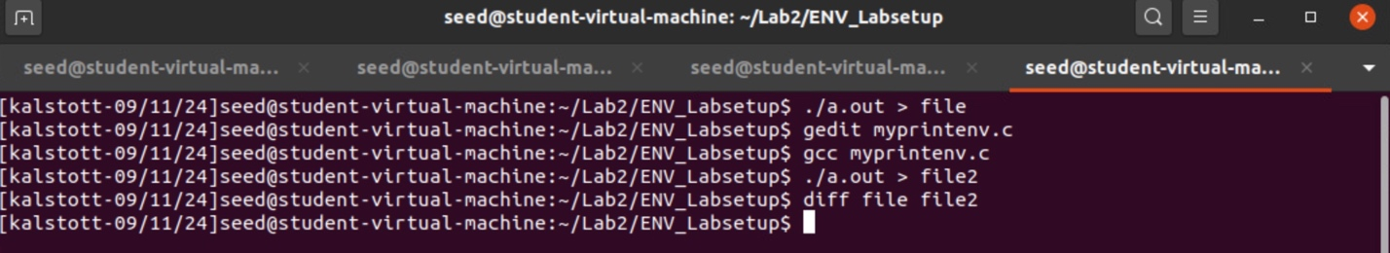

We then compile using "gcc myprintenv.c". We also run our program and save our output into a file with the same commands from the first step but this time saving it to a file named “file2”.

We then compare the differences of these two files. Since file is a child process and file2 is the parent process the results that should come back should be the same. The reason this happens is because the parent process is the original process so we can expect the environment variables in the “file” to match since this was the child process. The lesson here is that environment variables are inherited by the child process from the parent process. These are the same set of env variables.

TASK 3

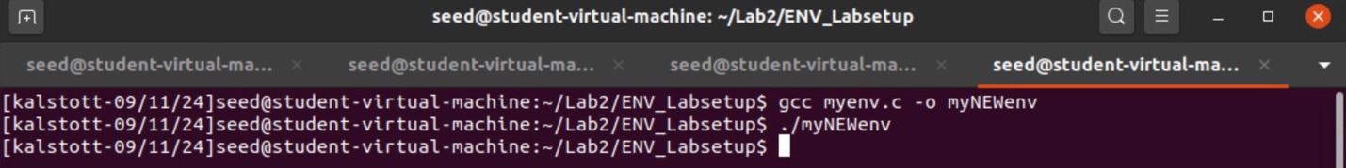

Step 1 – After we downloaded the zip file needed and acquired the myenv.c, we had to compile and run the program which are the commands “gcc” to compile and the “./myNEWenv” which runs the executable we had created and renamed from the following command. “This program simply executes a program called /usr/bin/env, which prints out the environment variables of the current process.” Due to our the value of NULL being passed in the envp[] argument, there should be no environment variables passed to /usr/bin/env. This explains our results in which we saw, /usr/bin/env print nothing, this shows us and confirms that no environment variables are available currently where we are at.

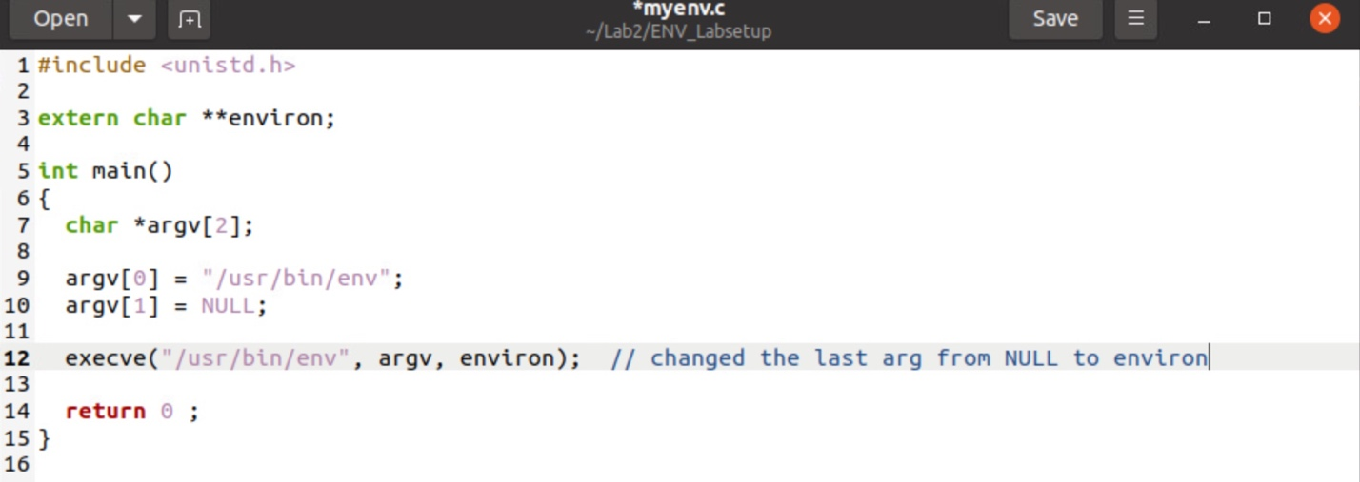

STEP 2 – In this step we had to change the invocation of execve() in Line ➀ to the following; execve("/usr/bin/env", argv, environ). We are now specifically passing the current process’s environment variables to the new program.

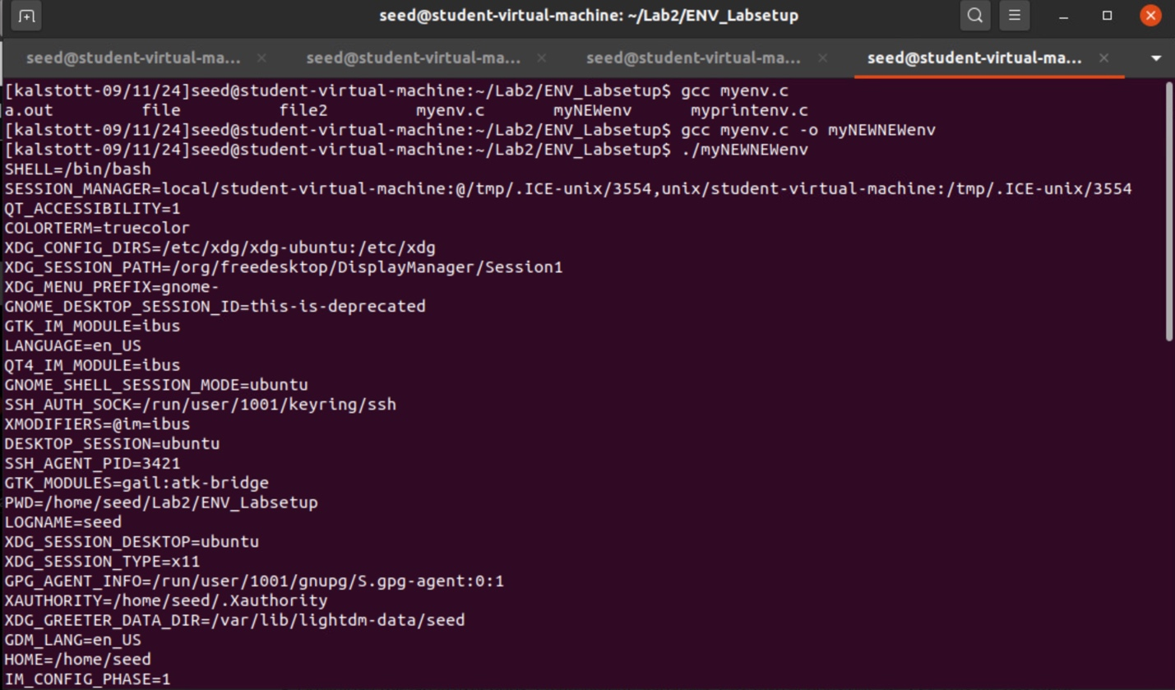

Step 3 – This is how the new program gets its environment variables. We had to compile and run our new program, using the commands “gcc myenv.c -o myNEWNEWenv” allowing us to compile and rename followed by running the executable which is the command “./myNEWNEWenv”, which prints out current env variables of our new program which is myNEWNEWenv. The reason on why this happens is explained above when we changed our NULL value in our argument to environ which specifically allows us to pass the current process’s environment variables to the new program.

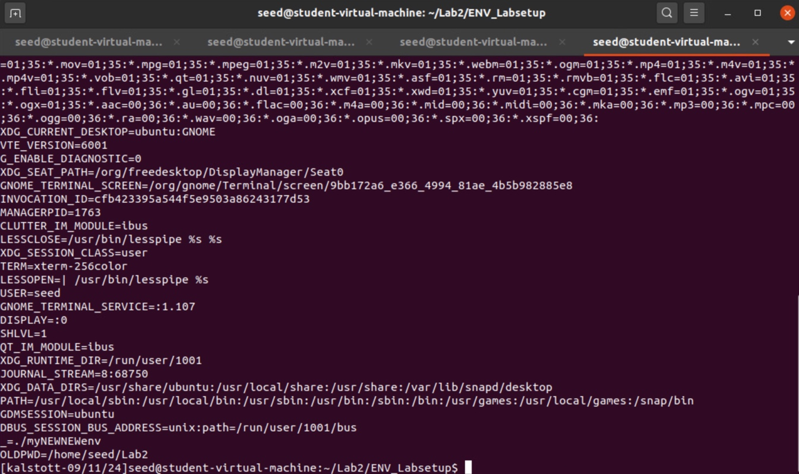

TASK 4

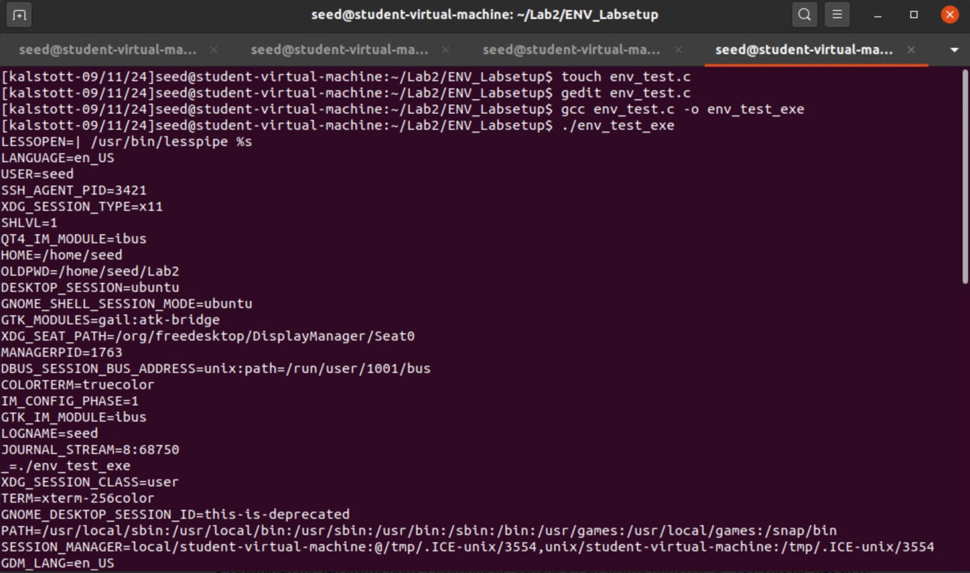

Step 1 – In this step we were tasked with seeing how environment variables are affected when a new program is executed via the system () function. We started off with creating our file by touch and gedit to put the code into the file we created. After this we compile and rename our executable. From there we ran our executable and as you can see in our code we use the system () function. This function executes "/bin/sh -c command", i.e., it executes /bin/sh and asks the shell to execute the command. This command allows for us to see how environment variables of the calling process is passed to the new program /bin/sh.

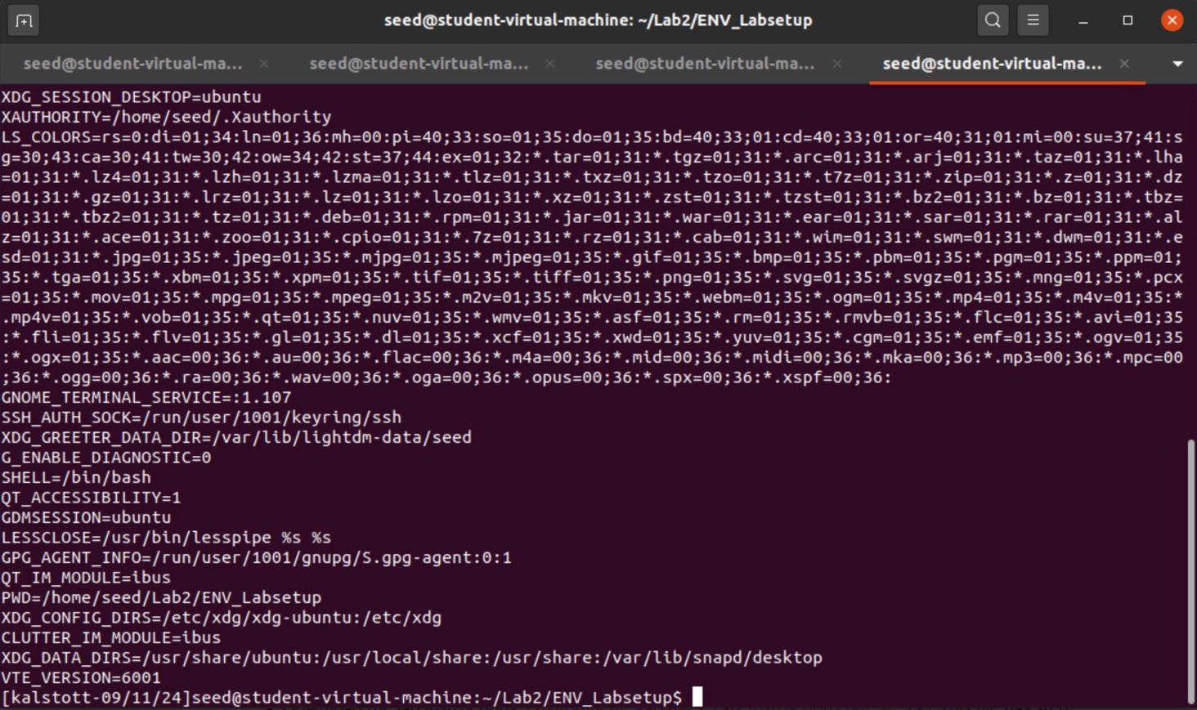

My .c file that I created with the code we used which prints out current env variables for the new executable that we created which was env_test_exe.

By using system (), the environment variables of the calling process is passed to the new program /bin/sh.

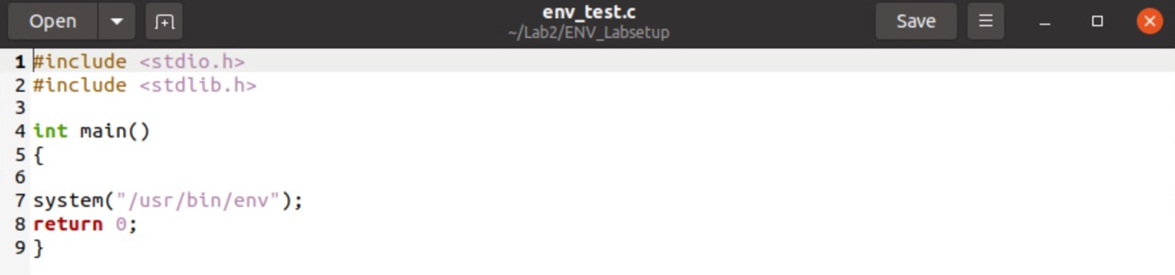

TASK 5

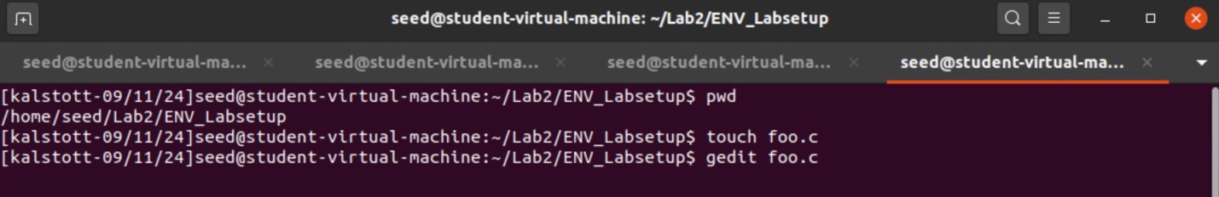

Step 1 – We were tasked with writing and create the following program foo that can print out all the environment variables in the current process. We do so by our typical commands of touch to create the file and gedit to edit the file and put our code into it.

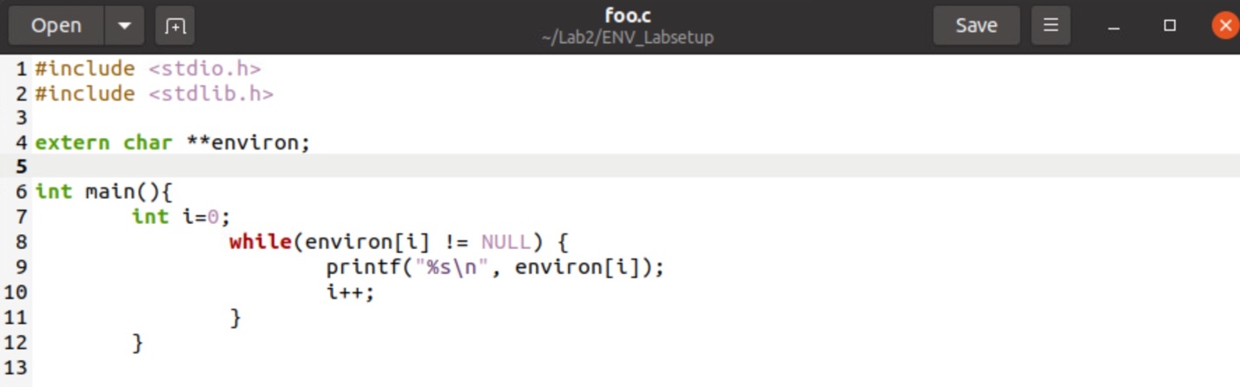

Foo.c file created with code that print out all the environment variables in the current process.

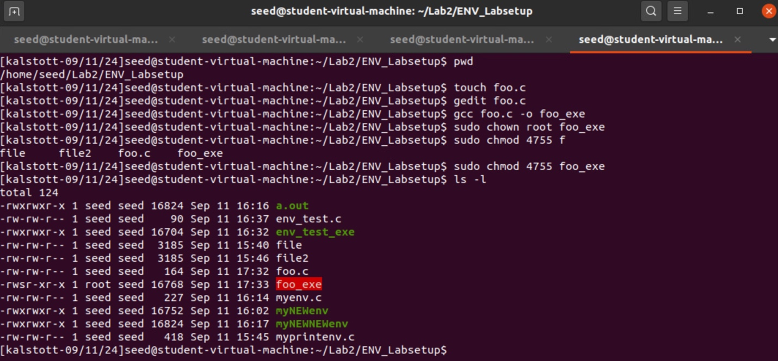

Step 2 – After editing the file we change its ownership to root, change the permissions to 4755 and make it a Set-UID program. Before we do this however, we had to be sure to compile our file and rename it to out executable which is “foo_exe”.

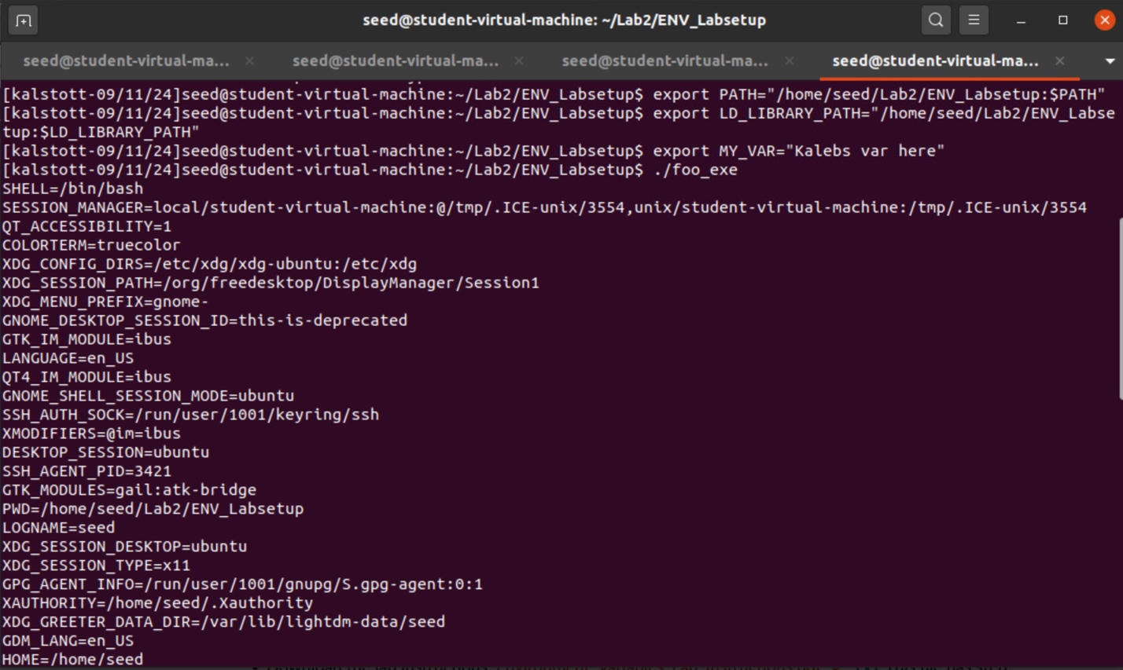

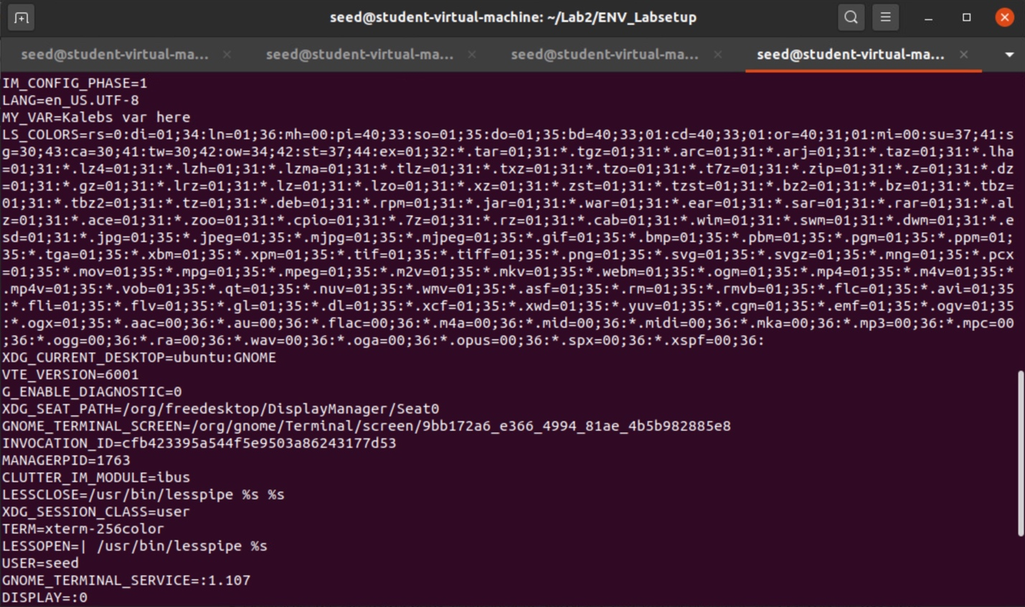

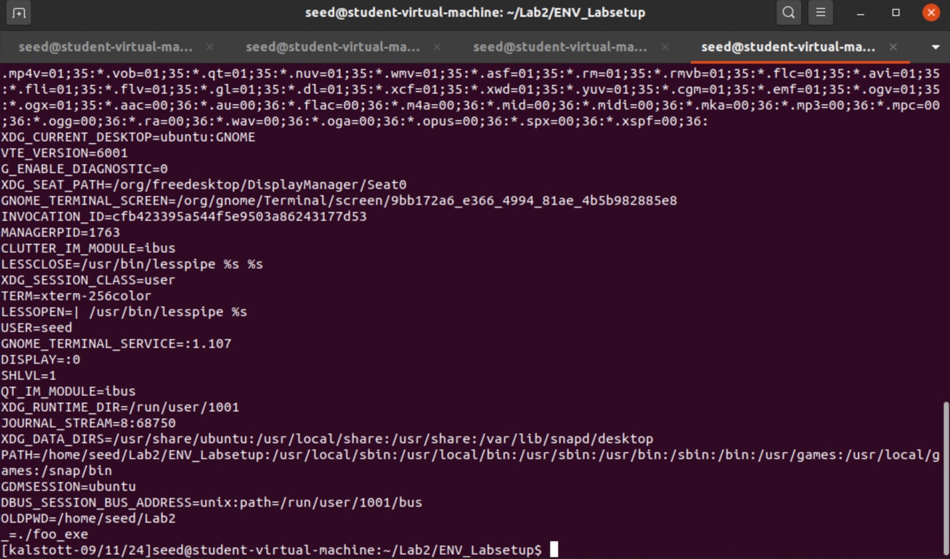

Step 3 – In this step the three screenshots above are what I will be describing. We used the export command to set our three environment variables in which we are using in this task. The three environment variables set here are PATH, LD_LIBRARY PATH, and my own custom environment variable of MY_VAR. These three variables are set in our user shell process in which we then run our foo_exe. When we ran the program, we can see that the shell forks a child process and uses the child process to run the program. When you look at the above screenshot, I was able to find the environment variables created by me which were the MY_VAR and PATH. I failed to see the LD_LIBRARY PATH and thought that this may be due to security reasons due to not wanting others to create custom libraries. This was the only weird exception that I have concluded in this task.

TASK 6

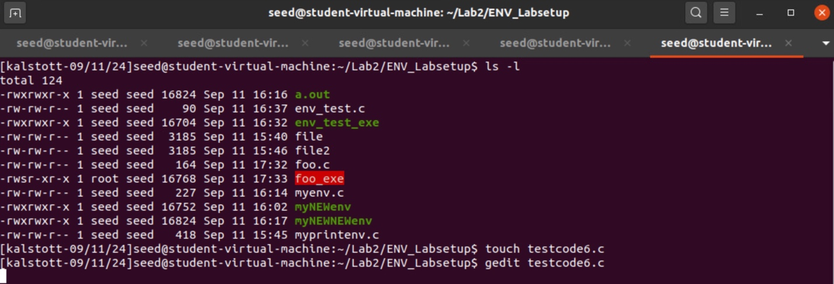

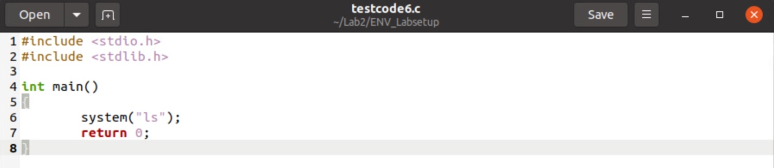

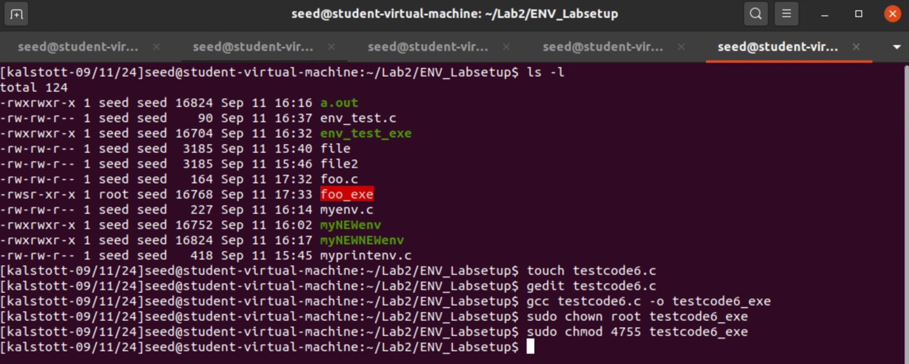

Step 1 – Per usual now we had to create our file and modify the file to have our code in the file after this we had to change owner to root owner as well as the permission to make this program a Set-UID program. We do so by the commands of touch to create our file, gedit to modify, compile using gcc and to rename our executable now, followed by sudo chown, and sudo chmod to change ownership and permission.

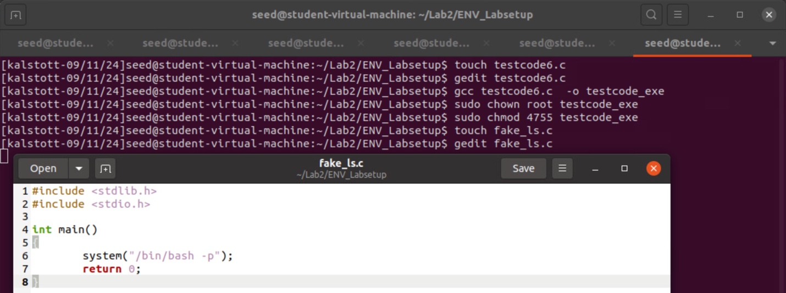

Step 2 - This is our own Malicious code that we have created.

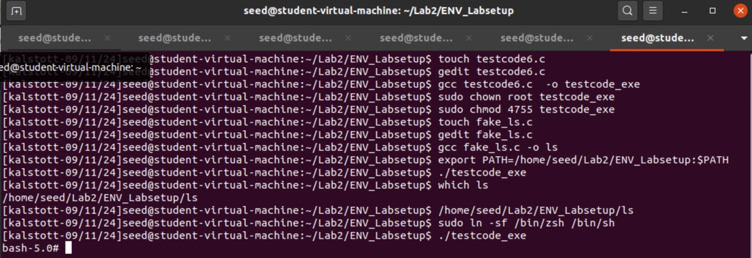

Step 3 – In this step it is key to note here that by renaming our file to “ls” and modifying the environment variable of PATH to point to our current position in which directory we are in. We can hit on our “ls” executable before the actual ls command showing the above results of being able to spawn a new shell. The reason on why this happens is because system(“ls”) does not specify the absolute path, so by changing our environment variable of PATH the program will search directories in the PATH to find an executable which just so happens to be our malicious code for the user.

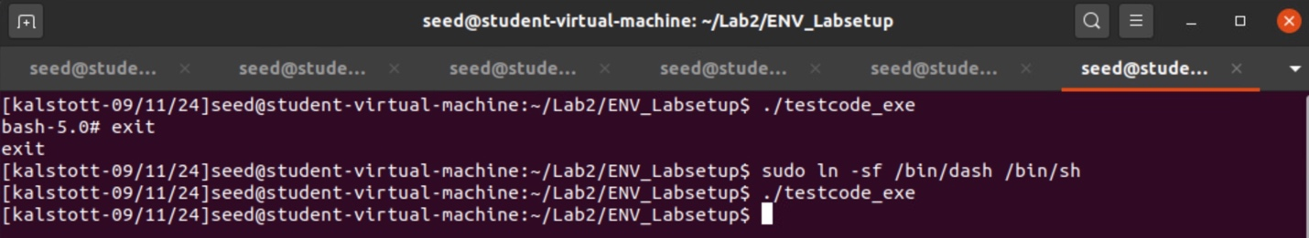

Step 4 – Since our victim program is a Set-UID program, the countermeasure in /bin/dash can prevent our attack. To do so we had to link /bin/sh to another shell that does not have a countermeasure. As you can see in the above screenshot this does indeed block the attack due to this countermeasure. Before we were able to execute this attack due to /bin/sh being linked to another shell that does not have such a countermeasure.

Task 7

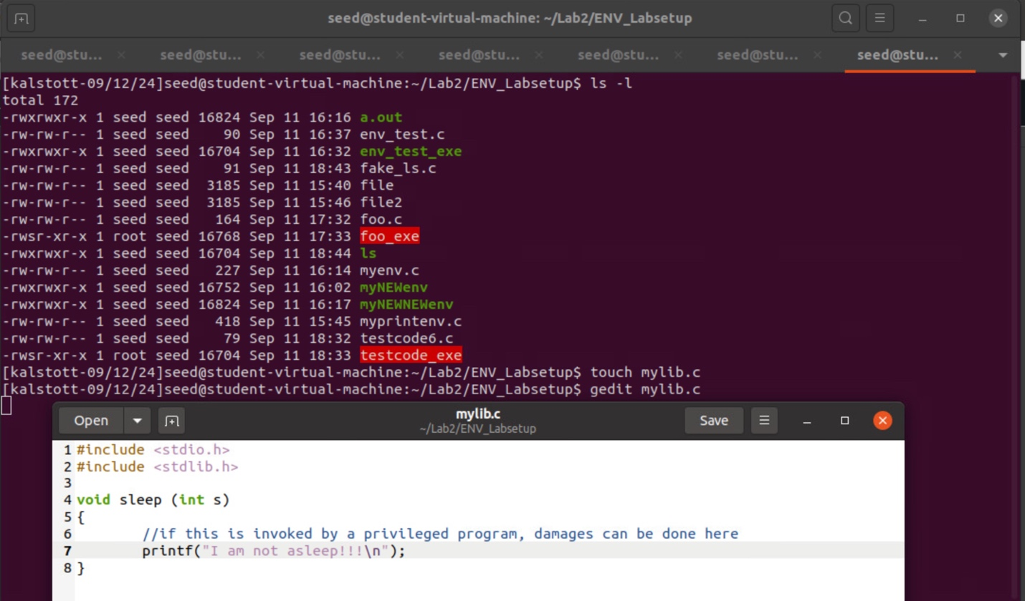

Step 1- We start this task off with being challenged to create our own dynamic link library. We do so by creating our program named mylib.c which allows us to override the sleep() function in libc. We do so by touching out file creating it and followed by gedit to modify our file with the code needed to override the sleep() function.

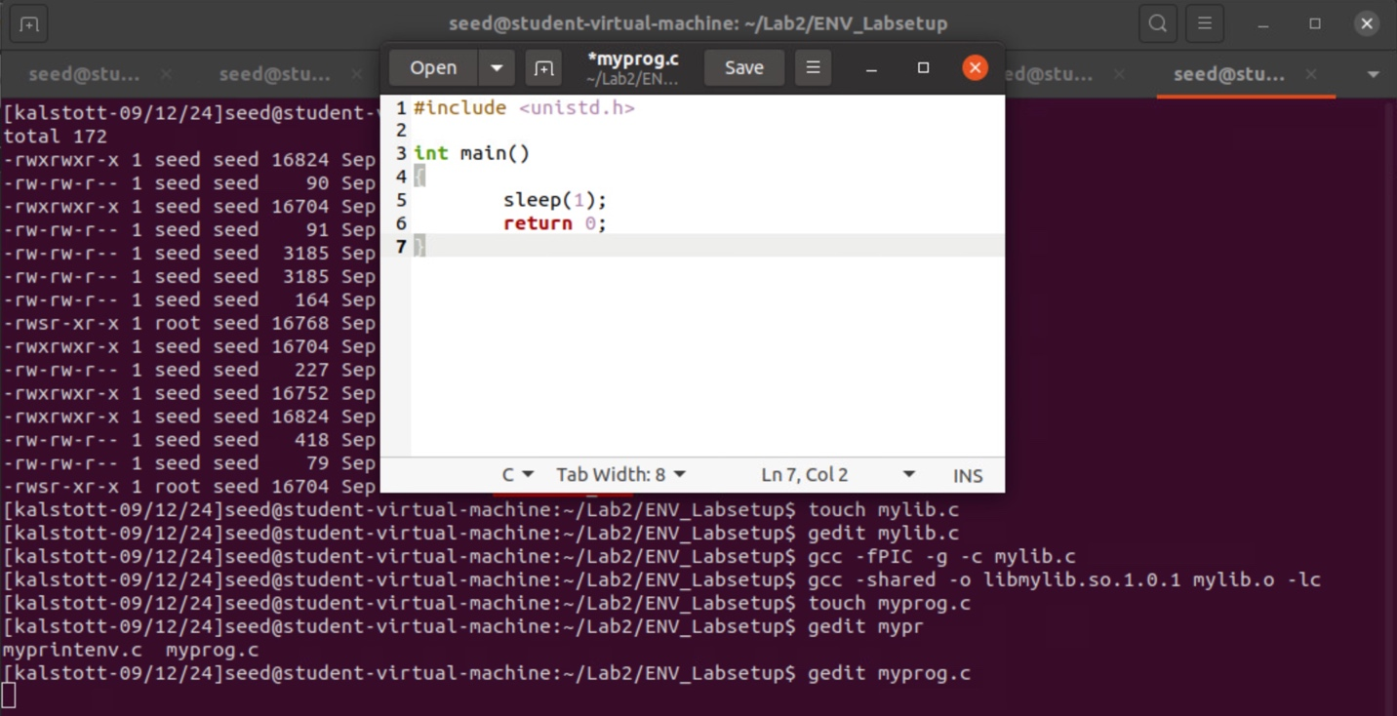

Step 2 – We follow the task by compiling our file with the gcc command which with the -shared allows us to creates a shared library instead of an executable, the -o specifying the output file name for the shared library, our object file linked to the shared library being mylib.o, followed by lastly -lc which allows us to link against the standard C library.

After this step it was important to create our program which we did by the usual touch and gedit to modify with the C file in the screenshot above.

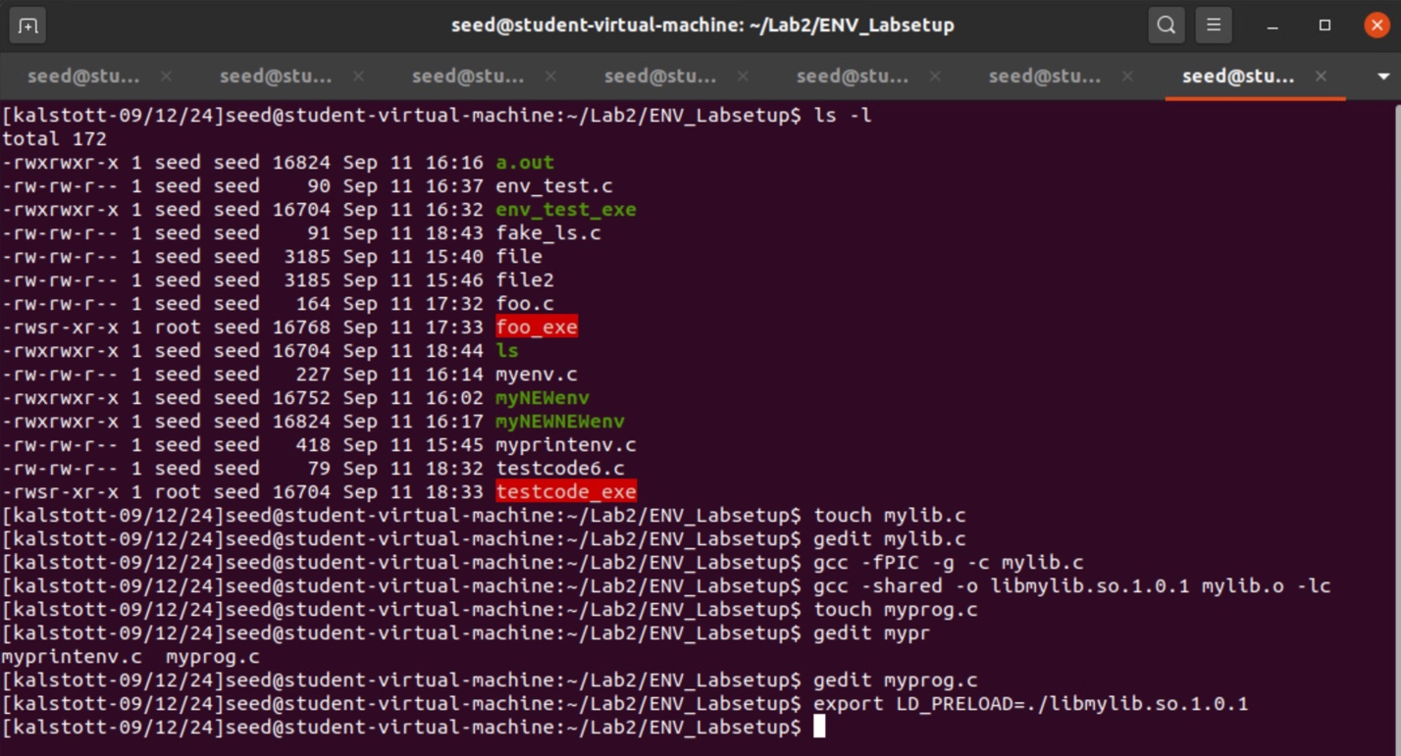

Step 3- In this step we had to set the LD PRELOAD environment variable by using the command export. This allows us to set the environment variable of LD_PRELOAD to the specified output file name which is the shared library. In our case it was our libmylib.so.1.0.1.



Step 4 – After compiling the following program and renaming it to myprog with the gcc -o command, this should be in the same directory as the dynamic link library libmylib.so.1.0.1.

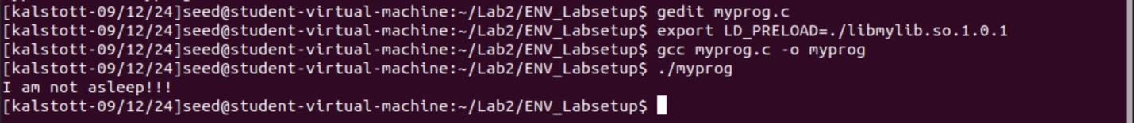

Step 5 – Run myprog as a regular program and ran as as a normal user. In this step our LD_PRELOAD overrides the default sleep() function with the custom one from libmylib.so.1.0.1 making our output, I am not sleeping!.



Step 6 – Run myprog as a Set-UID root program and ran as a normal user. This output is as expected due to the security placed on Set-UID programs. The system prevents dangerous environment variables like LD_PRELOAD from being applied to Set-UID programs to avoid privilege escalation vulnerabilities. This is the reason as to why we hit on the sleep in comparison to our printf statement of I am not sleeping!

Note – Here the commands I ran were the sudo chown root to change ownership to root, as well as sudo chmod 4755 to change permission of program, making this a Set-UID program. Followed by running the program.



Step 7 – Run myprog as a Set-UID root program followed by exporting the LD PRELOAD environment variable again in the root account and running it. The LD_PRELOAD environment variable is still affective due to the execution because it is set in the root environment. Explaining why we get the output that we do here.

Note – Followed the steps here by making Set-UID program, had to sudo su to switch to root user followed by the export command for LD_PRELOAD environment variable.

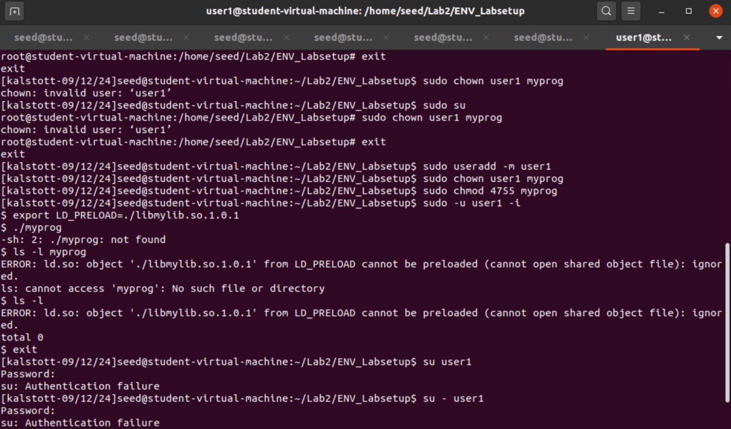

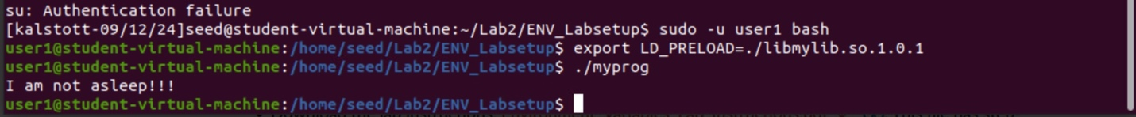

Step 8 – Run myprog as a Set-UID user1 program (i.e., the owner is user1, which is another user account), followed by exporting to the LD PRELOAD environment variable again in a different user’s account (not-root user) and running it.

Note – The commands taken here were useradd to add user1. Followed by making the owner of the program, myprog, user1 as well as changing it's permissions to 4755 of the program. We then were asked to switch into another user’s account done so by using the sudo command above. Once in the users account, we use the export command to set LD PRELOAD environment variable again and run the program.

The reason on why we get the output we do here is because when a Set-UID program is executed by a non-privileged user with LD_PRELOAD the environment variable is ignored due to security reasons. My guess is to why this is prevented is due to potential privilege escalation through environment variables by other users. Another reason I can think of is not wanting users to have access to custom libraries as well as modifying libraries for malicious intent.

It is important to note here that the User1 was not created and so with the following commands of useradd we were forced to create a User1 to assign to this program. After doing so you can see that I failed a couple of times trying to get into the other shell which was the User1 shell. After following the command sudo -u user1 bash we were able to run this program in the bash shell of User1. In which we can see the outcome of the attack.

**Why we saw different outputs even though we are running the same program?**

The reason on why we saw different outputs even though we are running the same program is due to the LD_PRELOAD environment variable affecting our dynamic linking behavior which can override shared library functions like we talked about when we used the -share in our gcc command allows us to compile, rename, and override shared library functions in the C library. But it is also important to note here that with Set-UID programs the security measures prevent LD_PRELOAD from being accessed when a non-privileged user tries to modify or change this behavior of our Set-UID program. This shows us and ensures that privilege escalation and elevated privileges cannot misuse or implement malicious custom libraries.

LOOK BELOW FOR A LAUGH

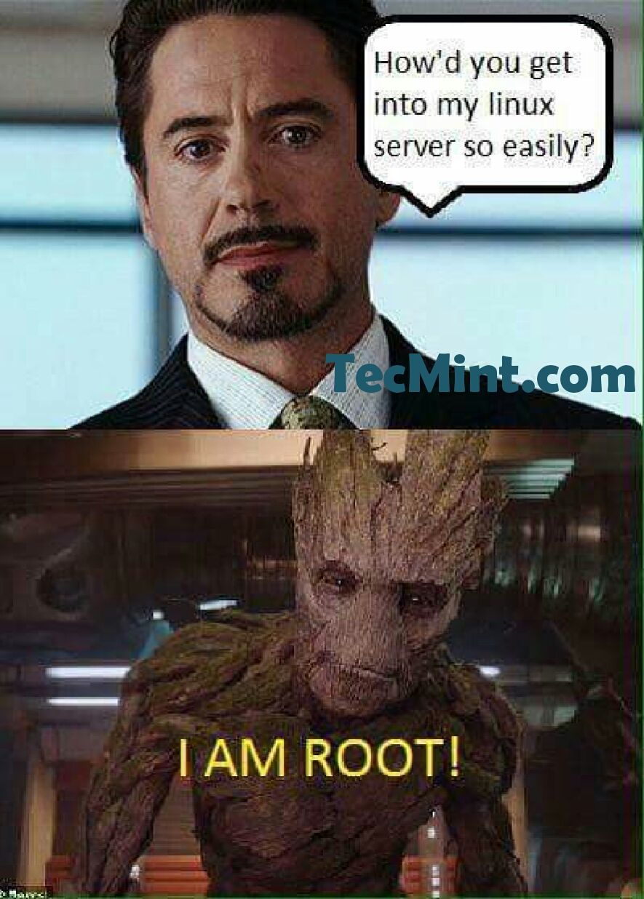

**Extra Credit?**

Why do submarines all run Linux?

Because you can’t open Windows underwater

Another funny joke/pic